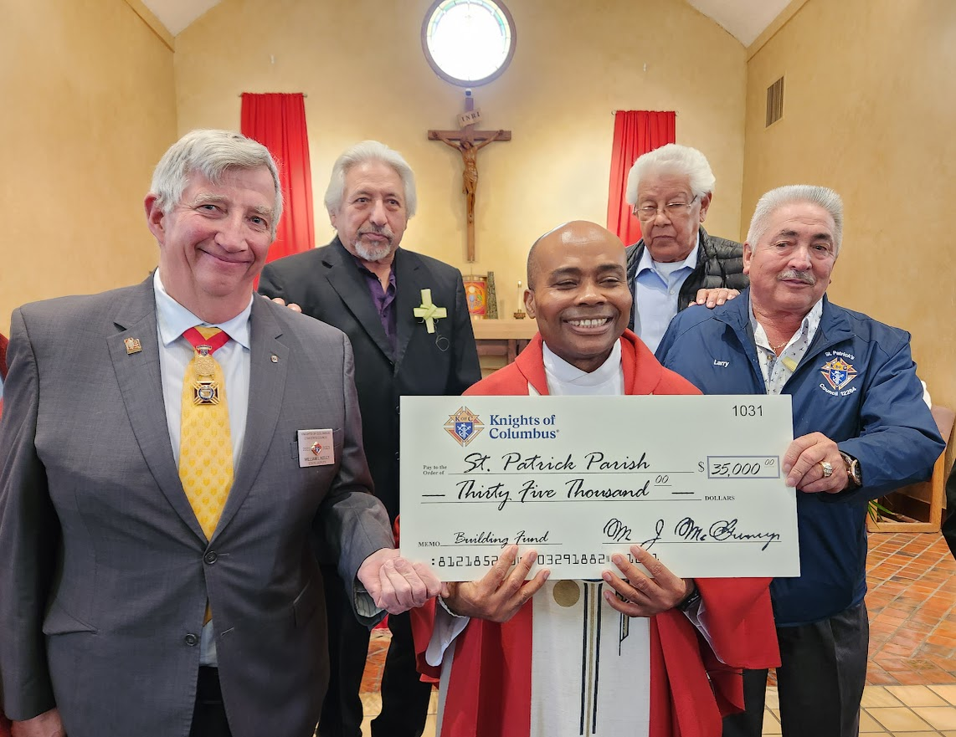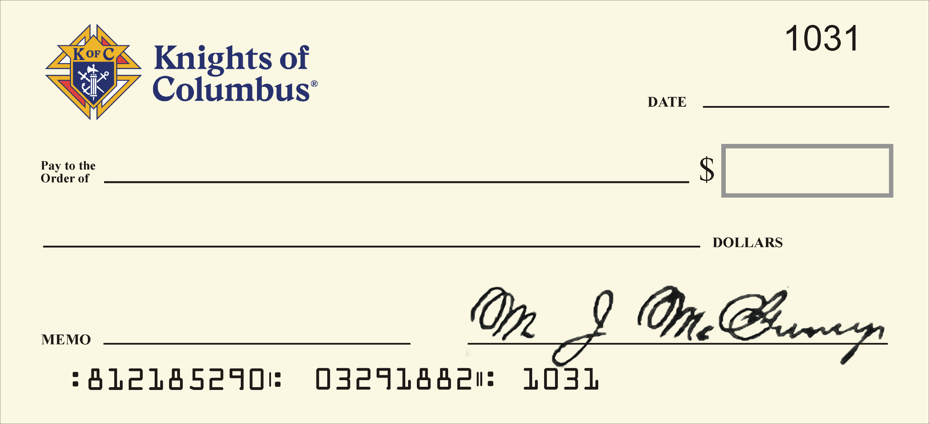

* This file as a width of 22” because that is as wide as Word will let me produce. Because the background of the check is a .PNG file, it can be printed to a size up to 48” without significant loss of quality.
* This file is designed for desktop computer use. It will not work as intended on mobile devices.
* The check is in color. To save some money you can print in black and white.
* Since available fonts vary from computer to computer, use the ones you want in the text boxes. Just make sure they fit; you may have to adjust the size of the font to fit available spaces. A “handwritten” look is typical.
  + Microsoft supplies the following “handwritten” fonts with Windows: Ink Free, Segoe Print (used in the example check above), and Segoe Script. Please, no Comic Sans. If you feel adventurous: https://www.1001fonts.com/handwritten-fonts.html
* The check number, routing number and account number cannot be changed. The check number is the month/day Blessed McGivney was beatified. The non-valid routing number is Blessed McGivney’s birth month, day, and four-digit year, followed by the two-digit year of his death. The account number is the month, day, and four-digit year the order was founded. The signature is his, cleaned up as best I could.

To print:

1. **Save As** a PDF file, **do not** print to PDF.
2. Send as an attachment via email or upload to your print provider’s web site. You can save to a thumb drive as well.
3. When printing, tell the printer the size to which you want to print. Let the print provider scale it to the proper width.
4. Tell them then if you want it in color or B&W.
5. You can get it printed directly to foam core OR print to plain paper (glossy not recommended, you can get glare that makes taking a good picture not as easy.)

If printing on paper, try to get some poster board and use either spray adhesive or two-sided tape to stick the check to the poster board. Unreinforced plain paper will   
blow in the wind or tear easily, or both. I recommend using a paper trimmer usually available at a print provider to trim the edges of the check to size.

Comments and suggestions to:   
Andy Airriess  
[aairriess@msn.com](mailto:aairriess@msn.com) *Printed at 24” size*

**Your Jurisdiction/Council/Assembly**

**9 June, 2023 June/NN/NNNN**

**Special Olympics of Utah**

**Ten Thousand Six Hundred Seventy-Six 40**

**For the athletes! June/NN/NNNN**

**10,67640** 00