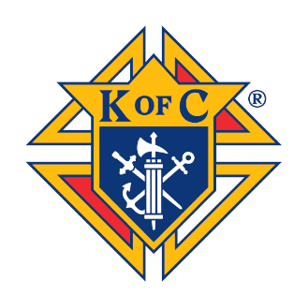
Knights of Columbus – Utah State Council
Substance Abuse Awareness Poster Contest
Participation Form
Due By: February 21
PLEASE INDICATE THE NUMBER OF PARTICIPANTS IN YOUR COUNCIL CONTEST:
AGE GROUPS 8-11 12-14 TOTALS
ALCOHOL AWARENESS _____ _____ _____
DRUG ABUSE _____ _____ _____
TOTAL _____ _____ _____

PERSONAL COMMENTS OR OBSERVATIONS CONCERNING THE KNIGHTS OF COLUMBUS SUBSTANCE ABUSE AWARENESS POSTER CONTEST:

CONTEST PARTICIPATION REPORT FORM: Immediately following the local council contest, the grand knight should complete and submit the Substance Abuse Awareness Poster Contest Participation Form (4001-Utah) to the State Poster Contest Chairman. This form provides the State Council officers with valuable participation statistics as well as feedback about the program in general.

SIGNED: __________________________ _____________ _____________
Grand Knight Council Number City/Town

