Click on some text to edit it, you will see the outline for the text box for that piece of text. You will likely have to change the font for the handwritten text. I used Designer1, but use anything you like. Except Comic Sans, please. The more it looks like handwritten, the better. Consider just printing out a blank check and writing out all the info yourself. *Don't forget your council name and number!*
After you fill in the text, from Word, print the check to a PDF file and email it to the nearest FedEx Store, Office Max, Stapes, or other print provider. If you send them a Word file, they might not have the fonts you have used and the check will look different than you want. Also, consider printing the check on a pastel blue, green or yellow paper for some color. Consider signing the check with a Sharpie. Also consider printing 2 of the checks you want ot present, so you have a backup.
This check is designed to print black and white on an 11x17 piece of paper.The routing and account numbers in the check below have been modified.
Use double-sided tape or a spray-on adhesive to attach the printed check to a piece of cardboard or foam core. If you use paste there will more likely be some bleed-through. After check is dry, THEN trim it with a boxcutter, utility knife, or Exacto blade.
Trim Here

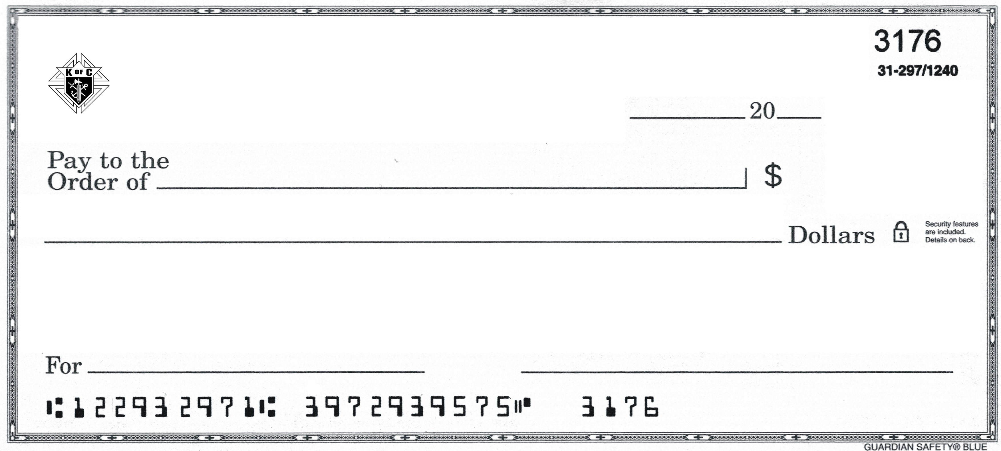
Your name
00/00
Who you are writing your check to
Knights of Columbus
Your Council Name and Number
The Cause
---The amount written out---⁰⁰
000.⁰⁰
yy

